Table 1: The explanation of Initial Dispatch Codes (IDC)
Colors | Triage Criteria | Essential Response
Red | Critical emergency patients | Responsible to pateint with Basic Life Support Unit: (BLS) within 4 mins after accident then responsible to pateint with Advance Life Support unit (ALS) within 8 mins after accident.
Yellow | Urgent emergency patients | Responsible to pateint with BLS within 8 mins after accident then responsible to pateint with First Response Unit (FR) within 15 mins after accident
Green | Not urgent emergency patients | Responsible to pateint with BLS within 8 mins after accident.
White | General patients | Responsible to pateint via telephone referral program and consider to BLS
Black | Not patients | No responsible to pateint

Table 2: The 25 main of symptom categories
Code | Symptom | Code | symptom
1 | Abdominal/Back/Groin Pain | 14 | O.D./Poisoning
2 | Anaphylaxis/Allergic Reaction | 15 | Pregnancy/Childbirth/Gyn.
3 | Infectious Disease | 16 | Seizures
4 | Bleeding (Non-traumatic) | 17 | Sick (Unknown)/Other
5 | Breathing Difficulty | 18 | Stroke (CVA)
6 | Cardiac Arrest | 19 | Unconscious/Unresponsive/  Syncope
7 | Chest Pain/Discomfort/Heart Problems | 20 | Pediatric Emergencies
8 | Choking | 21 | Assault/Trauma
9 | Diabetic | 22 | Burns - Thermal/Electrical/Chemical
10 | Environmental/Toxic Exposure | 23 | Drowning/Near Drowning/Diving or Water-related Injury
11 | --Not define symptom-- | 24 | Falls/Accidents/Pain
12 | Head/Neck | 25 | Motor Vehicle Accident (MVA)
13 | Mental/Emotional/Psychological | - | -

Table 3. Functionalities of the Triage mobile application
Function | Propose | How to use | Benefits | Graphical design
1.Triage | To identify IDC | Interview patient or consider patient habit by following the questions of CBD in application question by question. The result will show IDC to requesting a pre-hospital resources. | IDC can scope an appropriate requesting to pre-hospital resources.  The IDC together with part of suggestion where patient waiting in pre-hospital should be transferred. | 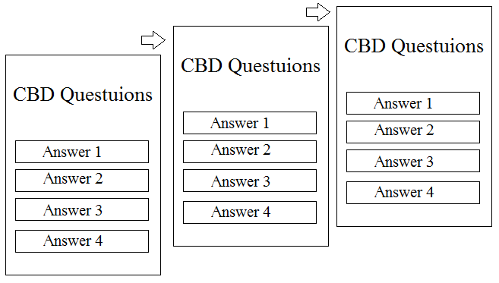  Point of design:  1.quickly accessible to triage  2.triage accuracy presentation  3.quickly accessible to a suggestion  4.direct manipulation for easy remembering  5.menu selection replace keyboard using
2.Finding responsibility of emergency care unit | To show nearby emergency care unit and a phone number | This function show emergency care unit based on Google map Application programming interface (API) with shortest transferring time consideration. | Patient or staff will have an information of emergency care unit which was ordered by transferring time from current location. | 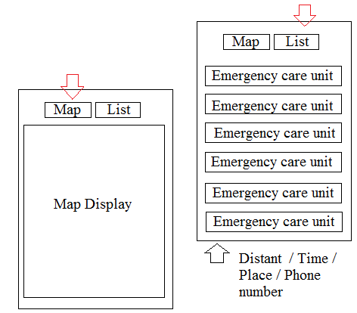  Point of design:  1.quickly accessible  2.accessible timing  3.menu selection replace keyboard using  4.reduce short term memory load
3.Patient triage log file | To check the triage information | Patient or staff can find the previous information of IDC code to identify the requesting of pre-hospital process | Log file can provide triage information to inform the pre-hospital process and confirm triage information. | 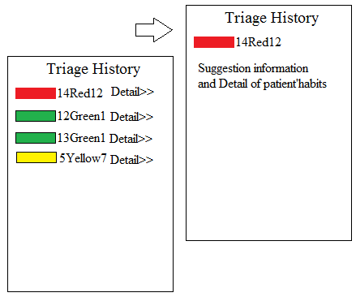 Point of design:  1.practical used  2.design dialog yield closure  3.simplicity  4.adequate presentation of information
4. Exporting IDC information | To send the information of IDC to associate emergency person | Patient or staff can send doctor or provincial emergency care unit a result of IDC which contains the detail of patients’ habits from the questions of CBD. | Provincial emergency care unit can use that information for preparing emergency resources when patient is transferring. | 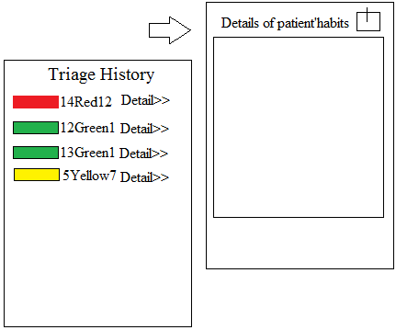 Point of design:  1.practical use  2.convenience  3.simplicity  4.adequate presentation of information

Table 4: Points of consideration for the application testing
Testing Criteria | Proposes | Methods
1. CBD questions flow assessment | - Correct or incorrect IDC in each symptom | - 25 symptoms were tested and compared with step by step of CBD question  -Testing by comparing with CBD handbook case by case which checked by medical emergency doctor
2. Triage time evaluation | - Time of testing for using application, open handbook and emergency medical staff. | -Testing by comparing with simulated scenario and comparison time for using application, open handbook and emergency medical staff  - Using independent sample t-test analysis to compare triage time consuming between application and staff experiences
3. Application usability test | - Consider as user friendly and practical uses in real operation | - Evaluating by 10 emergency staffs who were selected as a sample group. Application testing and questionnaire were used.  - Nielsen’s ten usability heuristics mixed with the human-centered theory, and Eight Golden Rules of interface design were used for testing for application performance in term of usability and user friendliness.

Table 5: Scenario test comparison for triage time testing and triage result
Patient habits | Application | Open Handbook | Experienced staff
Scenario 1 : Environmental/Toxic Exposure  1.conscious or breathing  2.unable to speak normally (work of breathing) | 5 seconds  IDC :14 Red 2  Critical Patient | 13 seconds  IDC :14 Red 2  Critical Patient | 4 seconds  IDC :14 Red 1  Critical Patient
Scenario 2: Environmental/Toxic Exposure  1.conscious or breathing  2.no asthma  3.breathe fast  4. age <20 | 8 seconds  IDC :14 Red 2  Critical Patient | 14 seconds  IDC :14 Red 2  Critical Patient | 6 seconds  IDC :14 Red 2  Critical Patient
Scenario 3: Anaphylaxis/Allergic Reaction  1.conscious  2.breathing  3.speak normally  4.fainting  5.drug allergic | 20 seconds  IDC :  2 Yellow 4  Urgent Patient | 28 seconds  IDC :  2 Yellow 4  Urgent Patient | 15 seconds  IDC :  2 White 2  General Patient
Scenario 4: Anaphylaxis/Allergic Reaction  1.unconscious  2.responding to other  3.breathe fast  3.speak normally  4.asthma  5.age <20 | 15 seconds  IDC :  2 Red 2  Critical Patient | 18 seconds  IDC :  2 Red 2  Critical Patient | 10 seconds  IDC :  2 Yellow 8  Urgent Patient

Table 6: Cross matrix usability test result
 | User Motivation
Function Test |  | Usability difficulties | Bug founding | Doubt visual representation | Doubt on usage | Missing information | Misunderstand | Total
Function Test | 1. Triage | 1 | 0 | 3 | 2 | 0 | 6 | 12²
Function Test | 2. Finding responsibility of emergency care unit | 2 | 0 | 2 | 0 | 4 | 1 | 8³
Function Test | 3. Patient triage log file | 0 | 0 | 1 | 3 | 0 | 3 | 7
Function Test | 4. Exporting IDC information | 3 | 0 | 2 | 3 | 0 | 4 | 13¹
Function Test | Total | 6 | 0 | 7³ | 8² | 4 | 13¹ | 22

